Android Architecture
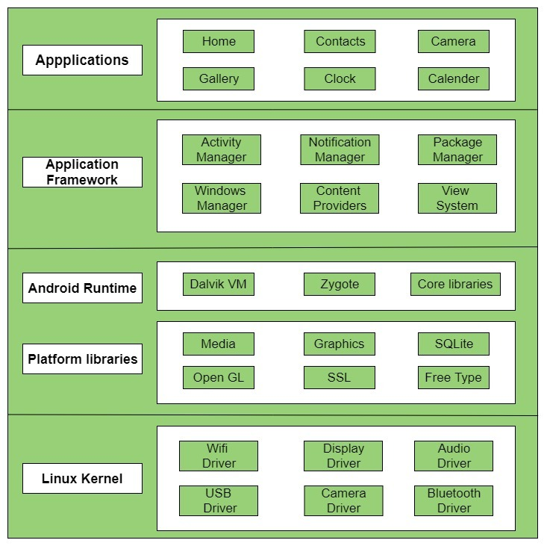

what is android ?
It is based on Linux
it is os
Middleware
Application
software development kit (sdk0)

what is Application Framwork ?
Application framwork layer provide higher level services to application in the form of java classes.
application developers allowed to make use of these services in their application .

it provide different services like Activity manager , notification manager,view system,package manager,location manager ,resources manager, content provider.

1) Power manager

Android power manager uses wakelock and time out mechnisms to switch state of system power consumption decreases.

Android power manager currently support screen,keyboard,buttons,backlight and brightness of screen

wakelock means in is running in dalvik which can prevent the system from entering a sleep and suspend state.

PARTIAL_WAKE_LOCK (cpu running ,screen might not be on) maintained in kernal
SCREEN_DIM_WAKELOCK (dim screen)
SCREEN_BRIGHT_WAKELOCK (bright screen)
FILL_WAKE_LOCK (full device is on)

2)Resource Manager

Resource Manager provides access to non code resource such as localized string,graphics and layout files.

Resource are external files that are used by your code and compiled into your applications at build time.

XML,PNG,JPEG,BITMAP,String,anaimation.

Two type of resources

1.Default-no need to configuration use current config.
2.alternative-need to specific config like any high quality annimation or different lanaguages.

3)Activity Manager

activity manager class gives information about and intract with activities services and containaing processes.

Ex if we open camera then click photo then resume sum time we destroy alos app

Managing the activity lifecycle

onCreate()

onStart()

onResume()

onPause()

onStop()

onRestart()

onDestroy()

4)content provider

Ex-DB
if we request read data then get response.
If we wnat access data in content provider we use content resolver object
content resolver communicates with provider object.
getContentResolver() its work is do CRUD operation .
cursor loaded is run at backgorund and its give the content back to ui.

Required Method

onCreate()
query()
Insert()
update()
Delete()
grtType()

SQLite
it is open source sql database that store data to a text file on a device.
no need of connection like jdbc.
it is used to store data .

content provider is used to share data between two application .

5)Package Manager

used to retrieve various kind of information related to application packages
that are current install on the device.

install ,uninstall,upgrade.

getPackageManager().
All install apk are store in xml file.
InstallPackage()
install app are store in system/app
package.xml==store info and permissions
permission are ==name,package,Protection

process to install

add package
determine a location for package install
app directory
determine uid
set permission

6)window Manager

it is display type of screen like rotation ,which window are visible and how they are laid on screen.
Window has session
window can have one or more surface
floating window vs default window.
Dialog is example

7)Notification manager
a Notification is a message you can display to the user outside of you application normal ui.
We use notification compact builder object for create and contain specification.
Object must contain follwing info
a small icon by setSmaillcon()
a title ,setContenttitle()
Detail text ste by steContentText()

what is Dalvik virtual Machine ?

Register based virtual machine.
It was designed and written by Dan Bornstein.

Working of DVM
The Java Compiler(javac) converts the Java Source Code into Java Byte-Code(.class). Then DEX Compiler converts this (.class) file into in Dalvik Byte Code i.e. “.dex” file.
Register-based models are good at optimizing and running on low memory. They can store common sub-expression results which can be used again in the future. This is not possible in a Stack-based model at all. Dalvik Virtual Machine uses its own byte-code and runs “.dex”(Dalvik Executable File) file.

Advantages
- DVM supports the Android operating system only.
- In DVM executable is APK.
- Execution is faster.

Disadvantages
- DVM supports only Android Operating System.
- For DVM very few Re-Tools are available.
- App Installation takes more time due to dex.
- More internal storage is required.

Application runtime –
Android Runtime environment is one of the most important part of Android. It contains components like core libraries and the Dalvik virtual machine(DVM). Mainly, it provides the base for the application framework and powers our application with the help of the core libraries.

Platform libraries –
The Platform Libraries includes various C/C++ core libraries and Java based libraries such as Media, Graphics, Surface Manager, OpenGL etc. to provide a support for android development.
- Media library provides support to play and record an audio and video formats.
- Surface manager responsible for managing access to the display subsystem.
- SGL and OpenGL both cross-language, cross-platform application program interface (API) are used for 2D and 3D computer graphics.
- SQLite provides database support and FreeType provides font support.
- Web-Kit This open source web browser engine provides all the functionality to display web content and to simplify page loading.
- SSL (Secure Sockets Layer) is security technology to establish an encrypted link between a web server and a web browser.

Linux Kernel –
Linux Kernel is heart of the android architecture. It manages all the available drivers such as display drivers, camera drivers, Bluetooth drivers, audio drivers, memory drivers, etc. which are required during the runtime.
The Linux Kernel will provide an abstraction layer between the device hardware and the other components of android architecture. It is responsible for management of memory, power, devices etc.
The features of Linux kernel are:
- Security: The Linux kernel handles the security between the application and the system.
- Memory Management: It efficiently handles the memory management thereby providing the freedom to develop our apps.
- Process Management: It manages the process well, allocates resources to processes whenever they need them.
- Network Stack: It effectively handles the network communication.
- Driver Model: It ensures that the application works properly on the device and hardware manufacturers responsible for building their drivers into the Linux build.

Hardware Abstraction Layer(HAL)
it is bridge.
it is used to communicate between android framwork and Linux kernal
it contain garphics,audio,camera,blutooth,GPS,radio,wifi
Linux is designed for handle only system call
Android framwork communicate with underlying hardware through java apis and not system calls
it generate calls which understood by kernel
The hardware abstraction layer (HAL) provides standard interfaces that expose device hardware capabilities to the higher-level Java API framework. The HAL consists of multiple library modules, each of which implements an interface for a specific type of hardware component, such as the camera or bluetooth module. When a framework API makes a call to access device hardware, the Android system loads the library module for that hardware component.

